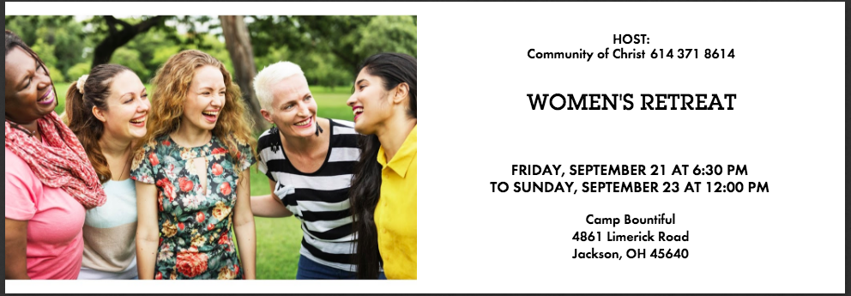

Evangelist Ruth Campbell, Camp Pastor
What are the quiet dreams you have in your heart? What is the passion you would chase if you could? What joy awaits you? You are invited to take some time apart. Bask in the beauty of Camp Bountiful and share with other women as we help each other bring forth the gifts that are in each one of us. Lisa Williams will share how she has been led on a new adventure; the goal of which is to enhance the lives of children and what better place to start than with encouraging women to seek the highest expression of themselves? Choose from mini-classes on the following topics:
- Prayer by Ruth Campbell
- How to Worry Less and Enjoy Life More by Marilee Martens
- Physical Fitness by Jennifer Richardson
- Gratitude by Lisa Williams
- Begin with the End in Mind by Debbie Galbraith
- Creating Beauty in Your Physical Space by Delanne Carlson
- Turning Grief into Strength by Sara Brown
- Accountability Partners by April Beck
- Self Care: Avoidance or Facing Your Fears by Morgan Martens
Also available:
Gel Manicures $25; Gel Pedicures $35, provided by a professional beautician. (For scheduling purposes, please e-mail Lisa43567@gmail.com by September 1, 2018 if you would like a manicure or pedicure.)
Please bring the following snack that coincides with the first initial of your last name. If your last name begins with: A-F Soda Pop, G-L Juices, M-R Healthy Snack, S-Z Munchies
Check in: 6:30-7:30 pm Friday, Sept. 21 Departure: 12 noon Sunday, Sept. 23
REGISTRATIONS SHOUD BE MAILED OR EMAILED TO Betty Jo Reed by September 14, 2018 (or Sept. 9th for a reduced rate)
NAME________________________________________________________________________
TELEPHONE__________________________________________________________________
ADDRESS____________________________________________________________________
CITY/ZIP______________________________________________________________________
EMAIL_______________________________________________________________________
SPECIAL NEEDS/FOOD_________________________________________________________
Please circle all that apply:
I am attending the entire weekend and registered before Sept. 9th $60.00
I am attending the entire weekend and registered after Sept. 9th $70.00
I am attending Saturday only and have enclosed $55.00
Due to economic hardship, I need help with registration, but I can pay _________
I can help another sister attend and have enclosed extra _________
MAKE CHECKS PAYABLE TO BETTY JO REED, AND MAIL TO:
1387 GERANIUM DRIVE, BLACKLICK, OH 43004.
CALL BETTY JO REED AT 614-371-8614, OR EMAIL bettyjoreed@twc.com
FOR LATE REGISTRATIONS.

